# Team 139

**Cyber Security**

**Smart Internz - Exploring Cyber Secuirty: Understanding Threats and Solutions in the Digital Age**

****

**Date: 05/03/2025**

**Team Members:**

|  |  |
| --- | --- |
| Date | 10 March 2025 |
| Team ID | Team ID : LTVIP2025TMID23912 |
| Projectc Name | Exploring Cyber Secuirty: Understanding Threats and Solutions in the Digital Age |
| Maximum Marks | 8 Marks |

|  |  |  |  |
| --- | --- | --- | --- |
| **S.no** | **Name of the Student** | **College** | **email** |
| 1. | N.Vasanth | Dr.Lankapalli Bullayya college | vasanthnambari77@gmail.com |
| 2. | P.Vinodh Kumar | Dr.Lankapalli Bullayya college | vinodhkumarpanthadi@gmail.com |
| 3. | M.Ratna Deepak | Dr.Lankapalli Bullayya college | deepakmaripi999@gmail.com |
| 4. | P.Pavan Kumar | Dr.Lankapalli Bullayya college | pssrchpavankumar2003@gmail.com |

1. **Contents**

**1.Introduction**

**1.1 Project Name**

**1.2 Abstact of the project**

**1.3 Scope of the project**

**1.4 Objective of the project**

**2. Ideation Phase**

**2.1 Various thoughts behind the project**

**2.2 Features i.e., Collection of data**

**2.3 Empathy Map**

**3. Requirement Analysis**

**3.1 Types of Vulnerabilities**

**3.2 Vulnerability assessment Report**

**3.3 Technology Stack**

**3.3.1 Tools Explored**

**4. Project Design**

**4.1 Nessus and Overview Of Nessus**

**4.2 Proposed Solution Template**

**4.3 Testing and findings of the Vulnerabilities**

**4.4 Understanding about the project**

**5. Project Planning and Scheduling**

**5.1 Project Planning**

**5.2 Project Tracking**

**5.2.1 Sprint Burndown chart**

**6. Functional and Performance Testing**

**6.1 Vulnerability report (impacts and identification)**

**7. Results**

**7.1 Findings and Results (Nessus and Vulnerability report )**

**8. Advantages and disadvantages**

**8.1 Pro's and Con's of the project**

**9. Conclusion**

**9.1 Summary of different stages**

**10. Future Scope**

**10.1 Future scope for different stages**

**11. Appendix**

**11.1 Github link & Project Demo video**

**1. Introduction**

**1.1 Introduction Of this Project:**

The rapid growth of the digital world has led to an increase in cyber threats, making cyber security a critical aspect of modern technology. Cyber criminals continuously develop sophisticated attack techniques that exploit vulnerabilities in networks, systems, and applications. This project explores the various types of cyber threats and the most effective security solutions to protect individuals, businesses, and governments in the digital age.

**1.2 Abstract of this Project:**

In an era where digital infrastructure is at the core of businesses, governance, and daily life, cybersecurity plays a vital role in ensuring data integrity, privacy, and resilience against cyberattacks. This project delves into the various types of cyber threats, including malware, phishing, ransomware, and insider threats, analyzing their impact on digital security.

The study examines fundamental cybersecurity strategies such as encryption, firewalls, multi-factor authentication, and endpoint protection, along with advanced techniques like threat intelligence, behavioral analytics, and Zero Trust Architecture. The research also highlights the importance of cybersecurity frameworks such as NIST, ISO 27001, and GDPR compliance in mitigating risks.

By incorporating real-world case studies, this project provides insights into cybersecurity best practices and defense mechanisms. The findings emphasize the need for a proactive approach, integrating security awareness, AI-powered threat detection, and incident response planning to enhance digital security in an ever-evolving threat landscape.

This research serves as a guide for cyber security professionals, businesses, and individuals to understand and implement effective security measures against emerging cyber threats.

## ****Designer****

## ****1.3 Scope of the Project****

### ****1. Research Scope****

✔ **Understanding different types of cyber threats**: Malware, phishing, ransomware, insider threats, DDoS attacks.

✔ **Studying cyber security frameworks and best practices**: NIST, ISO 27001, CIS Controls.  
✔ **Identifying vulnerabilities** in networks, cloud environments, and IoT devices.

### ****2. Cybersecurity Defense Strategies****

✔ **Implementation of firewalls, intrusion detection systems (IDS), and endpoint protection.**  
✔ **Role of encryption and secure authentication mechanisms** (MFA, biometrics).  
✔ **Network security strategies**, including segmentation and Zero Trust Architecture.  
✔ **Security awareness training** for individuals and organizations.

### ****3. Technical Scope****

✔ **Use of security tools**: Wireshark, Snort, and Metasploit for threat analysis.  
✔ **Implementation of SIEM** (Security Information and Event Management) for monitoring security events.  
✔ **Application of AI and Machine Learning** in threat detection and behavior analysis.  
✔ **Penetration testing and vulnerability assessment techniques.**

### ****4. Implementation Scope****

✔ **Real-world cyber attack case studies and their mitigation strategies.**  
✔ **Setting up an incident response plan** for handling security breaches.  
✔ **Implementing security policies** for businesses and cloud security measures.  
✔ **Developing a risk assessment framework** to identify potential security gaps.

### ****5. Industry & Business Scope****

✔ **Strengthening enterprise cyber security policies** to protect customer data.  
✔ **Enhancing financial sector security** against banking fraud and cyber attacks.  
✔ **Ensuring compliance** with regulatory standards such as GDPR, HIPAA, and PCI-DSS.  
✔ **Implementing cyber security strategies** in government, defense, and national infrastructure.

### ****6. Future Scope****

✔ **The role of AI and automation in next-generation cyber security.**  
✔ **Exploring the impact of quantum computing** on encryption and cryptography.  
✔ **Blockchain technology** for secure identity verification and data protection.  
✔ **Evolution of cyber security solutions** to combat emerging threats in smart cities and IoT environments.



****1.4 Main Objectives of the Project****

✅ **Understand Cyber Threats & Risks**

* Define cyber security and its importance in digital security.
* Categorize different types of cyber threats and their attack mechanisms.

✅ **Identify Cyber security Frameworks & Best Practices**

* Study security frameworks like NIST, ISO 27001, and CIS Controls.
* Explore regulatory compliance requirements for data protection.

✅ **Develop Cyber Defense Strategies**

* Implement endpoint security, network firewalls, and access control measures.
* Strengthen security awareness through training and simulated cyber attack exercises.

✅ **Integrate Threat Detection & Incident Response Mechanisms**

* Deploy SIEM tools for real-time monitoring of security threats.
* Automate cybersecurity responses with AI-driven security solutions.

✅ **Leverage AI & Machine Learning in Cyber security**

* Utilize AI-based threat detection systems for anomaly detection.
* Develop predictive security models to identify emerging threats.

✅ **Enhance Risk Management & Compliance**

* Align cyber security strategies with legal and compliance requirements.
* Conduct risk assessments to identify vulnerabilities and mitigate potential threats.

✅ **Explore Future Trends in Cyber security**

* Investigate the role of quantum computing, AI, and blockchain in cyber security.
* Develop new techniques to counter advanced cyber threats in the digital age.

✅ **Provide Practical Implementation & Case Studies**

* Analyze real-world cyber attacks and their impact on businesses and individuals.
* Develop cyber security policies based on lessons learned from historical cyber incidents.

**2 Ideation Phase:**

**2.1 Various Thoughts of Behind this Project:**

**Step 1 Various Ideas**

**Vasanth**

**Securing sensitive data from unauthorized access.**

**Preventing financial losses and reputational damage.**

**Enhancing threat detection and response.**

**Vinodh kumar**

**Ensuring privacy and security of personal information.**

**White-hat hackers strengthen security by identifying vulnerabilities.**

**Governments face cyber warfare and espionage threats**

**Ratna Deepak**

**White-hat hackers help improve security..**

**Regular updates, strong passwords, and awareness training**

**Governments enforcing cybersecurity laws and frameworks.**

**Pavan Kumar**

Could break traditional encryption

Governments face cyber warfare and espionage threats.

Increasing demand for skilled professionals.

**.**

**2.2 :Selecting some Features and Grouping Them**

**Data collection and Integration:**

SOAR platforms automate the process of collecting, integrating, and responding to security incidents. They help streamline workflows by integrating data from different security tools, providing automated responses based on predefined rules.

By collecting and integrating data from diverse sources, security teams gain a more holistic view of their environment. This enables better detection of complex or sophisticated attacks, including advanced persistent threats (APTs).

**AI Powered Analytics:**

AI-powered analytics in cybersecurity involves using artificial intelligence algorithms to process vast amounts of security data, detect anomalies, predict potential threats, and automate responses. By applying AI, cybersecurity systems can significantly enhance their capabilities

Machine learning is a subset of AI that enables systems to learn make decisions without explicit programming. ML algorithms can analyze historical data to understand the normal behavior of users and systems, and then flag anomalies that might indicate an attack.

**Risk Assessment:**

Risk assessment is a fundamental aspect of cybersecurity that helps organizations identify, evaluate, and mitigate risks to their digital assets. In the digital age, where cyber threats are constantly evolving, effective risk management is essential to protect sensitive data, maintain business continuity, and prevent financial and reputational damage. By assessing risks, organizations can prioritize their cybersecurity efforts and allocate resources effectively to reduce potential vulnerabilities.

**User Friendly Dashboard:**

In today’s rapidly evolving digital landscape, managing cybersecurity threats requires an efficient way to visualize, track, and respond to security incidents in real-time. A **user-friendly dashboard** is a key tool for cybersecurity professionals and organizations, enabling them to monitor security threats, manage risk, and make informed decisions more easily. By presenting complex data in a visually appealing, easy-to-understand format, a well-designed dashboard can improve response times, simplify risk management, and empower stakeholders to stay informed and act quickly.

**T**

**Trend Analysis:**

Trend analysis in cybersecurity involves the systematic review of data over time to identify recurring patterns, behaviors, or events related to cyber threats, vulnerabilities, and system performance. By analyzing trends, organizations can detect changes in the threat landscape, understand the frequency and severity of attacks, and anticipate future risks.

**Alerting and Reporting:**

**Alerting** refers to the automated notifications generated by security systems when they detect potential threats or unusual activities in a network, application, or system. Alerts typically contain information about the nature of the threat, its severity, and its potential impact. **Reporting**, on the other hand, involves documenting, summarizing, and analyzing security incidents, alerts, and system performance. Reports help organizations track their security posture over time, provide insights for decision-makers, and comply with regulations.

**2. 3 Empathy Map :**

**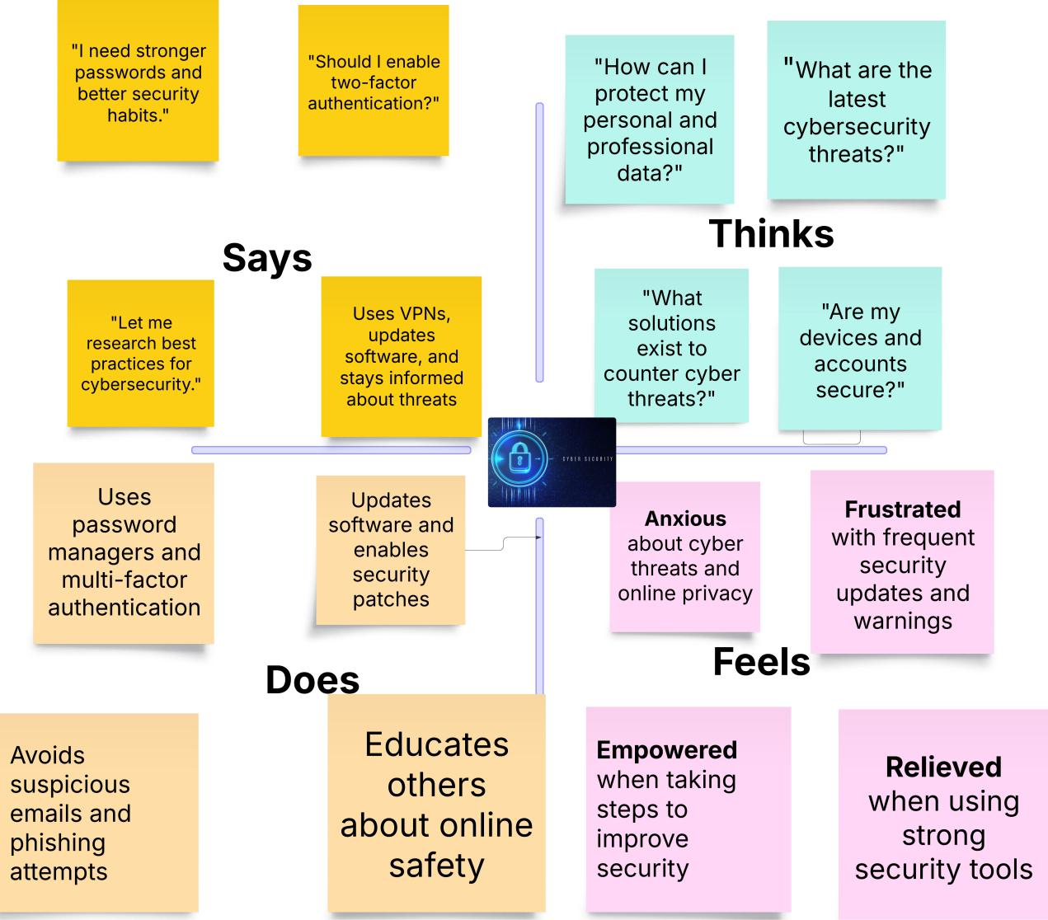**

**3 Requirement Analysis:**

**Stage-1**

3.1 Understanding Various Vulnerabilities:

**Top 5 Vulnerability Exploitation**

|  |  |  |
| --- | --- | --- |
| **S.no** | **Vulnerability Name** | **CWE-No** |
| 1 | XML External Entities (XXE) | CWE-611 |
| 2 | Buffer Overflow | CWE-120 |
| 3 | Remote Code Execution (RCE) | CWE-94 |
| 4 | Insecure API Exposure | CWE-201 |
| 5 | Insufficient Logging & Monitoring | CWE-778 |

**3.2 Solution Requirement**

**Vulnerability Name :**XML External Entities (XXE)

CWE-611

**OWASP Category:** Injection

**Description:**

Improper XML parsing allows attackers to access local files or internal networks.

**Business Impact:**

* **Data Exposure:** Attackers can exploit XXE to retrieve sensitive data, such as system files, configuration files, or even credentials stored on the server.
* **Denial of Service (DoS):** XXE attacks can exhaust system resources, causing applications to crash or become unresponsive.
* **Server-Side Request Forgery (SSRF):** Attackers can use XXE to send requests to internal services, bypassing security controls and accessing restricted areas.
* **File Disclosure:** XXE can be used to read arbitrary files on the server, leading to exposure of confidential business data.
* **Remote Code Execution (RCE):** In advanced cases, XXE can be exploited to execute commands on the server, leading to full system compromise.
* **Regulatory Non-Compliance:** Exposure of sensitive customer data through XXE attacks can lead to violations of compliance standards like GDPR, HIPAA, and PCI DSS, resulting in hefty fines and reputational damage.

**Steps to Identify:**

* Use Burp Suite with XXE payloads.
* Analyze XML-based API responses.
* Validate and sanitize XML input.
* Disable external entity processing in XML parsers.

**Vulnerability Name:** Buffer Overflow

CWE-611

**OWASP Category:** Memory Corruption

**Description:**

Buffer Overflow occurs when a program writes more data to a buffer than it can hold, causing adjacent memory to be overwritten. Attackers exploit this to execute arbitrary code, leading to full system compromise.

**Business Impact:**

* **System Crashes:** Exploiting buffer overflow can cause applications to crash, leading to service disruptions.
* **Remote Code Execution (RCE):** Attackers can inject and execute malicious code, gaining control over the system.
* **Privilege Escalation:** Buffer overflow vulnerabilities may allow attackers to escalate privileges, gaining higher-level access to systems.
* **Data Corruption:** Overwriting memory can lead to data corruption or loss, affecting system integrity**.**
* **Financial and Reputational Damage:** Organizations may suffer financial loss due to service outages, regulatory fines, and reputational damage.

**Steps to Identify:**

* Use fuzzing techniques to inject large inputs and monitor system behavior**.**
* Utilize static analysis tools to detect improper memory management.
* Review source code for unsafe functions like strcpy, gets, and sprintf.
* Enable memory protection mechanisms such as Address Space Layout Randomization (ASLR) and Data Execution Prevention (DEP).

**Vulnerability Name:** Remote Code **Execution (RCE)**

CWE-94

**OWASP Category:** Injection

**Business Impact:**

* **Complete System Takeover:** Attackers can gain full control over the affected system.
* **Data Theft and Exfiltration:** Sensitive information, including personal and financial data, can be stolen**.**
* **Propagation of Malware:** Attackers can install malware, including ransomware, to disrupt business operations.
* **Financial Losses:** Downtime, ransom payments, and regulatory fines can cause severe financial damage**.**
* **Reputational Damage:** Loss of customer trust and potential legal consequences.

**Steps to Identify:**

* Conduct code reviews to identify insecure function calls like eval() and exec().
* Use dynamic analysis tools to test application behavior against payloads.
* Check for improper input validation in APIs and user input fields.
* Perform penetration testing to simulate real-world RCE attacks.

**Vulnerability Name:** Insecure API **Exposure**

CWE-201

* OWASP Category: API Security

Description:

Insecure API exposure occurs when APIs expose excessive or sensitive data due to improper access controls, weak authentication, or poor data filtering.

**Business Impact:**

* **Data Breach:** Sensitive customer and business data can be accessed by unauthorized parties.
* **Regulatory Penalties:** Non-compliance with data protection laws (e.g., GDPR, CCPA) can result in fines.
* **Service Disruption:** Attackers may exploit API weaknesses to overload or disrupt service**s.**
* **Increased Attack Surface:** APIs are often publicly accessible, making them prime targets for attackers.

**Steps to Identify:**

* Use API security testing tools like Postman, Burp Suite, or OWASP API Security Testing Tool.
* Review API responses for excessive or unnecessary data exposure.
* Test authentication and authorization mechanisms for weaknesses.
* Perform penetration testing on exposed API endpoints.

**Vulnerability Name:** Insufficient Logging & Monitoring

* **CWE: CWE-778**
* **OWASP Category:** Security Logging & Monitoring Failures

**Description:**

Lack of proper logging and monitoring allows attacks to go undetected, making it difficult to identify security incidents, investigate breaches, and take corrective action in a timely manner**.**

**Business Impact:**

* Delayed Incident Response: Without adequate logs, security teams struggle to detect and respond to threats promptly.
* **Regulatory Non-Compliance:** Many data protection regulations (e.g., GDPR, HIPAA) require proper logging. Non-compliance can lead to hefty fines.
* Undetected Data Breaches: Attackers can exploit systems for prolonged periods without detection, increasing data theft risks.
* **Increased Attack Dwell Time:** The longer an attacker remains undetected, the more damage they can inflict on an organization's infrastructure.
* Forensic Challenges: Insufficient logs hinder the ability to investigate security incidents, making it harder to determine the cause and scope of an attack.
* **Reputational Damage:** Customers and partners may lose trust if a security incident remains undetected for a long time due to inadequate monitoring.

**Steps to Identify:**

* **Review Log Retention Policies:** Ensure logs are stored securely and retained for an appropriate duration.
* **Check for Security Alerts in SIEM Systems:** Utilize Security Information and Event Management (SIEM) tools to aggregate and analyze security events.
* Test for Missing or Incomplete Logs: Conduct audits to verify whether important security events (e.g., login failures, privilege escalations, API requests) are being recorded.
* **Implement Real-Time Monitoring:** Use automated alerting mechanisms to detect unusual system behavior.
* **Analyze Past Security Incidents:** Evaluate previous breaches to determine if insufficient logging contributed to delayed detection.

**3.3 Technology Stack**

**3.3.1 Tools explored in this project**

**1. Endpoint Security Tools:**

* **Antivirus/Antimalware Software:** Detects, prevents, and removes malicious software from individual devices.
* **Host-Based Intrusion Detection Systems (HIDS):** Monitors activities on individual devices for signs of unauthorized access or malicious behavior.
* **Endpoint Detection and Response (EDR):** Provides continuous monitoring, detection, and response capabilities on endpoints to combat advanced threats.

**2. Network Security Tools:**

* **Firewalls:** Hardware or software-based security devices that monitor and control incoming and outgoing network traffic based on predetermined security rules.
* **Intrusion Detection Systems (IDS) & Intrusion Prevention Systems (IPS):** Monitor network traffic for suspicious activities and take action to block or prevent potential threats.
* **Network Protocol Analyzers (e.g., Wireshark):** Used for troubleshooting, analysis, and security auditing of network traffic.

**3. Vulnerability Assessment Tools:**

* **Vulnerability Scanners (e.g., Nessus, OpenVAS):** Identify vulnerabilities, misconfigurations, and malware across various platforms.
* **Cloud-Based Assessment Solutions (e.g., Qualys):** Offer vulnerability management and assessment to identify, prioritize, and remediate vulnerabilities.

**4. Encryption Tools:**

* **Data Encryption Programs (e.g., PGP):** Provide cryptographic privacy and authentication for data communication.
* **Full-Disk Encryption Features (e.g., BitLocker):** Protect data on disk volumes.
* **SSL/TLS Toolkits (e.g., OpenSSL):** Implement protocols for securing communications over a network.

**5. Identity and Access Management (IAM) Tools:**

* **Directory Services (e.g., Active Directory):** Manage user identities and permissions in a networked environment.
* **Single Sign-On (SSO) Solutions:** Enable users to securely authenticate once and access multiple applications without re-entering credentials.
* **Multi-Factor Authentication (MFA):** Enhances security by requiring users to provide multiple forms of authentication, such as passwords, biometrics, or tokens.

**6. Security Information & Event Management (SIEM) Tools:**

* **SIEM Platforms (e.g., Splunk, LogRhythm, IBM QRadar):** Collect, analyze, and correlate security event data from various sources to provide real-time insights into potential security threats and incidents.

**4 Project Design:**

**Stage 2:**

**4.1 Nessus:**

**Nessus:** Nessus is a powerful vulnerability assessment tool developed by Tenable, widely used by security professionals to detect vulnerabilities, misconfigurations, and compliance issues in IT systems. It helps organizations proactively identify security risks and remediate them before they can be exploited by attackers.

One of the key strengths of Nessus is its comprehensive vulnerability scanning capabilities, which allow organizations to proactively detect security flaws before they can be exploited by attackers. The tool uses an extensive database of over 180,000 plugins, regularly updated to identify new vulnerabilities, misconfigurations, and outdated software. Nessus scans devices for open ports, unpatched software, weak passwords, and dangerous configurations that could lead to security breaches. It also detects malware, backdoors, botnet activity, and ransomware-related vulnerabilities, ensuring that security teams can take immediate action to mitigate risks. In addition to standard vulnerability scanning, Nessus provides compliance auditing to help organizations adhere to regulatory standards such as PCI-DSS, HIPAA, ISO 27001, NIST, and CIS benchmarks. This makes it an essential tool for companies that must meet strict security requirements.

While Nessus is highly effective, it does have certain limitations that security professionals should be aware of. Like many automated scanning tools, it can sometimes produce false positives, requiring manual verification of certain findings. Additionally, Nessus does not automatically remediate vulnerabilities—it provides detailed reports and recommendations, but fixing the issues requires manual intervention by IT teams. Another challenge is that large-scale scans can consume significant system resources, which may impact network performance if not properly configured. Despite these challenges, Nessus remains one of the most trusted tools in vulnerability management due to its accuracy, reliability, and continuous updates to stay ahead of emerging threats.

**4.2 Proposed Solution Testing and Findings;**

### ****Testing the Website Solution****

#### ****Types of Tests to Conduct:****

**Functionality Testing:**

* 1. **Goal:** Ensure all website features work as intended.
  2. **Tests might include:**
     1. Testing contact forms, search features, and navigation links.
     2. Verifying user registration/login processes.
     3. Checking that all interactive elements (buttons, drop-downs, etc.) function correctly.

**Usability Testing:**

* 1. **Goal:** Evaluate the user experience (UX) and ease of use.
  2. **Tests might include:**
     1. Gathering user feedback through surveys or usability sessions.
     2. Testing website navigation, content accessibility, and the clarity of calls to action (CTAs).
     3. Checking whether users can find the information they need quickly and easily.

**Performance Testing:**

* 1. **Goal:** Assess the website's load time and performance under various conditions.
  2. **Tests might include:**
     1. Load testing (how the site performs under different traffic loads).
     2. Stress testing (how it behaves when pushed beyond expected traffic levels).
     3. Checking page load times across various devices and networks.
     4. Testing for smooth multimedia (e.g., video or images) loading.

**Compatibility Testing:**

* 1. **Goal:** Ensure the website functions across different browsers, devices, and screen sizes.
  2. **Tests might include:**
     1. Verifying compatibility across browsers (Chrome, Firefox, Safari, Edge, etc.).
     2. Testing responsiveness on desktop, tablet, and mobile devices.
     3. Checking for any broken elements on different screen sizes and resolutions.

**Security Testing:**

* 1. **Goal:** Identify vulnerabilities and ensure user data protection.
  2. **Tests might include:**
     1. Penetration testing to detect vulnerabilities.
     2. Testing encryption for sensitive user data.
     3. Verifying protection against SQL injection and cross-site scripting (XSS).

**SEO (Search Engine Optimization) Testing:**

* 1. **Goal:** Ensure the website is optimized for search engines.
  2. **Tests might include:**
     1. Checking the use of meta tags, alt text, and other SEO best practices.
     2. Verifying that the website has a proper URL structure and sitemap.
     3. Testing for broken links and redirects.

### 2. ****Findings:****

Once you've completed these tests, you will likely uncover various findings based on the testing results. Some possible findings include:

**Functionality Issues:**

* + Broken links or non-functioning features (e.g., forms not submitting).
  + Errors in user flows (e.g., users are unable to complete a task such as purchasing or signing up).

**Usability Concerns:**

* + Users may struggle with navigation due to confusing menus or cluttered pages.
  + Calls to action might be unclear or too far down the page.
  + Some sections of the website could be difficult to read or use on smaller mobile screens.

**Performance Problems:**

* + Slow load times, especially for image-heavy pages.
  + Server response issues under heavy traffic (leading to timeouts or errors).
  + Mobile performance might lag due to unoptimized assets.

**Compatibility Issues:**

* + Some website features or layouts might not render correctly in certain browsers.
  + Mobile responsiveness may break on specific devices, such as larger tablets or smaller smartphones.
  + Certain interactive elements may not function on older browser versions.

**Security Vulnerabilities:**

* + Lack of proper encryption for sensitive data such as passwords and payment details.
  + Potential exposure to common cyber-attacks, such as SQL injection or cross-site scripting (XSS).
  + Missing security certificates or outdated software that could make the site vulnerable.

**SEO Findings:**

* + Missing alt text for images, hindering search engine indexing.
  + Poor keyword optimization, leading to low search engine rankings.
  + Broken or redirected links that can negatively affect SEO.

### 3. ****Next Steps Based on Findings:****

Once you’ve gathered your testing findings, you’ll want to address any issues found. Here’s a general approach:

* **Prioritize Issues:** Address critical issues (e.g., security vulnerabilities, major functionality bugs) first.
* **Fix Usability Issues:** Simplify navigation, improve the clarity of CTAs, and optimize content for mobile devices.
* **Optimize Performance:** Compress images, reduce the number of HTTP requests, and implement content delivery networks (CDNs).
* **Ensure Browser Compatibility:** Implement fixes for any rendering issues on different browsers and devices.
* **Improve SEO:** Address any SEO issues by fixing broken links, optimizing metadata, and improving content structure.

**4.4 Understanding about the project:** Exploring Cyber Secuirty: Understanding Threats and Solutions in the Digital Age

### ****Project Overview: "Exploring Cybersecurity: Understanding Threats and Solutions in the Digital Age"****

In the modern digital world, cybersecurity has become more critical than ever. With the rise of digital platforms and interconnected systems, cyber threats continue to evolve, posing risks to individuals, businesses, and governments. This project aims to explore the nature of these threats and the various solutions available to counteract them.

#### ****Objectives of the Project:****

**Understanding Cybersecurity Threats**:

* 1. Identify different types of cybersecurity threats that exist today.
  2. Understand how these threats impact organizations and individuals.
  3. Explore the tools and tactics employed by cybercriminals to exploit vulnerabilities.

**Understanding Cybersecurity Solutions**:

* 1. Analyze the best practices for protecting against cyber threats.
  2. Review modern cybersecurity solutions (e.g., firewalls, encryption, multi-factor authentication).
  3. Understand the role of both individuals and organizations in maintaining cybersecurity.

**Assessing the Current Landscape**:

* 1. Investigate how current cybersecurity measures are evolving to address new and emerging threats.
  2. Understand the ongoing challenges faced by cybersecurity professionals in keeping up with rapidly changing technology.

**5. Project Planning and Scheduling :**

**5.1 Project Planning:**

**P**roduct backlog, Sprint Schedule, and Estimation

Use the below template to create product backlog and sprint schedule.

|  |  |  |  |  |  |  |  |  |
| --- | --- | --- | --- | --- | --- | --- | --- | --- |
| **Sprint** | **Functional Requirement (Epic)** | **User Story Number** | | **User Story / Task** | | **Story Points** | **Priority** | **Team Members** |
| Sprint-1 | Data Collection | USN-1 | | Collect data from various cybersecurity websites like( Krebs on security,Info Security Magzine etc). | | 5 | High | Vasanth,Vinodh Kumar,Ratna Deepak,Pavan Kumar |
| Sprint-1 |  | USN-2 | | Use Real Time APIs to gather data. | | 3 | Medium | Vasanth,Vinodh Kumar,Ratna Deepak,Pavan Kumar |
| Sprint-2 |  | USN-3 | | Get various news about the different kinds of cybersecurity vulnerabilities like (XSS,RCE etc). | | 2 | Low | Vasanth,Vinodh Kumar,Ratna Deepak,Pavan Kumar |
| Sprint-2 | Processing | USN-4 | | Use of data processing platforms like (Apache Storm,SIEM etc). | | 5 | High | Vasanth,Vinodh Kumar,Ratna Deepak,Pavan Kumar |
| Sprint-2 |  | USN-5 | | Use of cybersecurity libraries like(scapy,cryptography etc) to work on the given data. | | 4 | High | Vasanth,Vinodh Kumar,Ratna Deepak,Pavan Kumar |
| Sprint-3 | User Interface | USN-6 | | Use of various coding languages like (Ruby ,Assembly language) and React.js helps to create a simple yet effective dashboard for the user. | | 5 | High | Vasanth,Vinodh Kumar,Ratna Deepak,Pavan Kumar |
| Sprint-3 |  | USN-7 | | Having a separate login implemented for users to see dashboard particular to their content . | | 3 | Medium | Vasanth,Vinodh Kumar,Ratna Deepak,Pavan Kumar |
| Sprint-3 | Data Visualization | USN-8 | | Use tools like DataDog,Loggly,QRadar etc to show various data in a more readable format to the user for easy to understand. | | 5 | High | Vasanth,Vinodh Kumar,Ratna Deepak,Pavan Kumar |
| Sprint-4 |  | | USN-9 | | Have a feature to ask user for their suggestions the regarding thr given task. | 2 | Low | Vasanth,Vinodh Kumar,Ratna Deepak,Pavan Kumar |
| Sprint-4 | Scalability | | USN-10 | | Use Docker , Kubernetes to scale the whole project. | 5 | High | Vasanth,Vinodh Kumar,Ratna Deepak,Pavan Kumar |
| Sprint-4 |  | | USN-11 | | Have a better databse system to store the real time and other various data. | 5 | High | Vasanth,Vinodh Kumar,Ratna Deepak,Pavan Kumar |

**5.2 Project Tracker, Velocity & Burndown Chart:**

|  |  |  |  |  |  |  |
| --- | --- | --- | --- | --- | --- | --- |
| **Sprint** | **Total Story Points** | **Duration** | **Sprint Start Date** | **Sprint End Date (Planned)** | **Story Points Completed (as on Planned End Date)** | **Sprint Release Date (Actual )** |
| Sprint-1 | 12 | 6 Days | 21 Jan 2025 | 26 Jan 2025 | 12 | 26 Jan 2025 |
| Sprint-2 | 12 | 6 Days | 28 Jan 2025 | 2 Feb 2025 | 08 | 3 Feb 2025 |
| Sprint-3 | 12 | 6 Days | 6 Feb 2025 | 11 Feb 2025 | 12 | 11 Feb 2025 |
| Sprint-4 | 12 | 6 Days | 14 Feb 2025 | 19 Feb 2025 | 10 | 20 Feb 2025 |

**Velocity:**

Imagine we have a 10-day sprint duration and the velocity

Of the team is 20 (points per sprint). Let’s calculate the teams average velocity (AV) per iteration unit (story points per day)

Average Velocity (AV)=Total Story Points / number of Sprints

=42/4 =10.5(approx.).

**5.2.1 The Sprint Burndown Chart:**

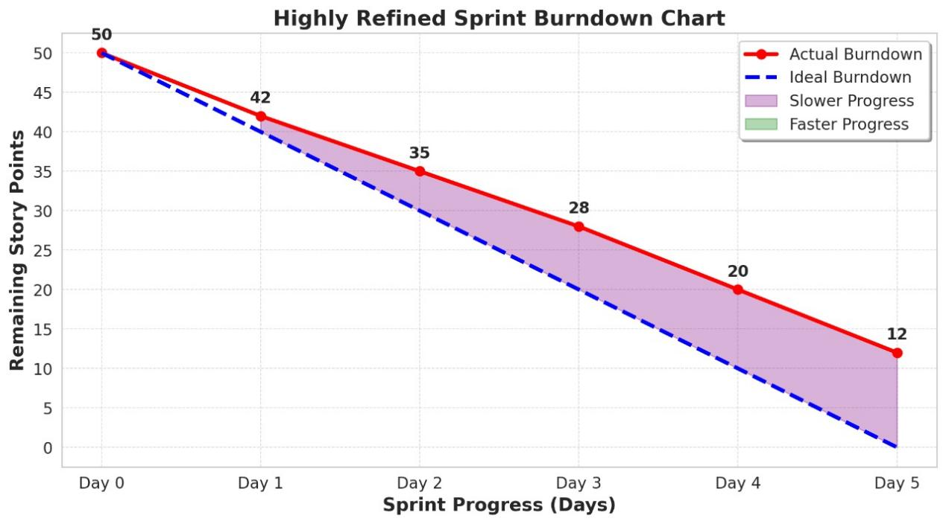

**Red Line (Actual Burndown):** Represents the real progress of the sprint.

**Blue Dashed Line (Ideal Burndown):** Represents the expected progress if work is completed at a steady pace.

**Shaded Areas and Their Meanings:**

**Purple Shaded Area (Slower Progress)**

* The space between the red line (actual progress) and the blue dashed line (ideal progress).

**Stage-2**

**Targeted Website:Google-Gruyere**

**IP Address:142.250.195.180**

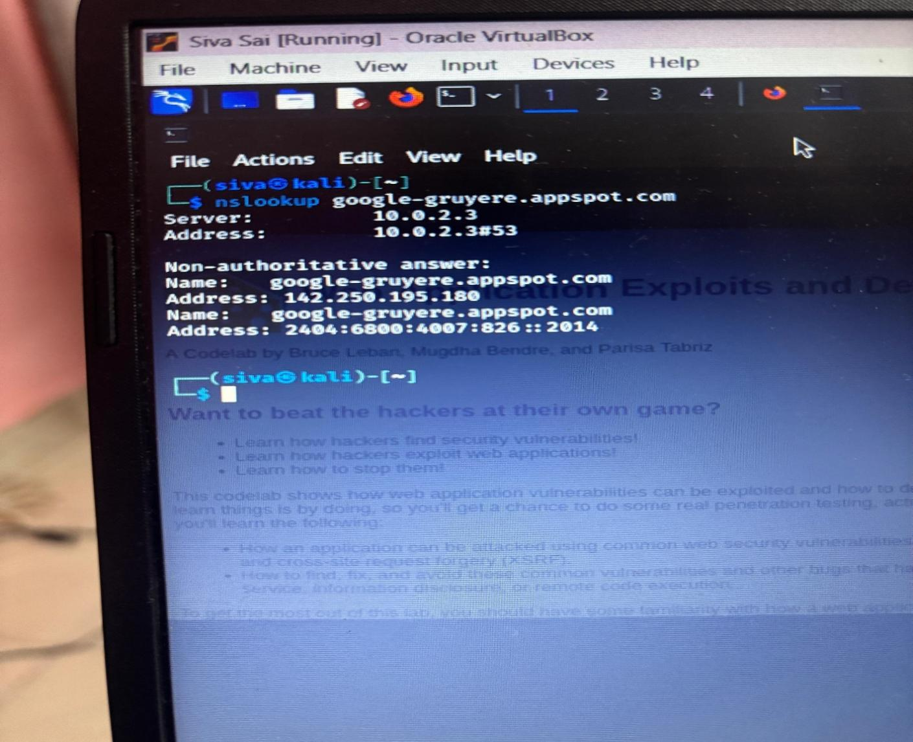

|  |  |  |
| --- | --- | --- |
| **S.no** | **Vulnerability Name** | **CWE-No** |
| 1 | **Path Traversal** | CWE-22 |
| 2 | **Insecure File Upload** | CWE-434 |
| 3 | **Cross-Site Request Forgery (CSRF)** | CWE-352 |
| 4 | **Clickjacking** | CWE-1021 |

**6.Functional and Performance Testing:**

**6.1: vulnerability Report(impacts and identifications):**

**Vulnerability Name: Path Traversal**

**CWE-No:** CWE-22

* **OWASP Category:** A05:2021 - Security Misconfiguration
* **Severity:** High
* **Plug in :** Burp Suite path traversal, OWASp ZAP,NIKTO
* **PORT:** 80 for HTTP

**Description:**

Path Traversal, also known as Directory Traversal or Path Reversal, is a high-severity web security vulnerability that occurs when an application improperly processes user-supplied input, allowing unauthorized access to files and directories outside of the intended scope. This vulnerability arises when an application accepts user input for file path references and does not properly sanitize or restrict it, enabling attackers to navigate beyond designated directories using sequences like ../ (dot-dot-slash). If successfully exploited, path traversal can allow attackers to read sensitive system files, extract credentials, access source code, modify system configurations, or even execute arbitrary code, depending on the severity of the misconfiguration.

Web applications and systems that handle files dynamically, such as content management systems (CMS), file upload/download features, document viewers, and APIs, are highly susceptible to path traversal attacks. The vulnerability is especially dangerous when combined with weak file upload mechanisms or improper server configurations, as attackers could exploit it to execute remote code execution (RCE) and fully compromise the system

**Bussiness Impact:**

**•** Data Breach & Confidentiality Loss

* Attackers can access sensitive system files, user credentials, financial records, or proprietary business data.
* Exposure of customer PII (Personally Identifiable **Information)** can lead to identity theft, fraud, and loss of user trust.

• Regulatory Non-Compliance & Legal Consequences

* Violates GDPR, HIPAA, PCI-DSS, and SOC 2 security standards, leading to heavy fines and legal penalties.
* Organizations may be subject to lawsuits, class-action cases, or government-imposed restrictions on operations.

**Vulnerability Name:** Insecure File Upload

**CWE-No:** CWE-434

**OWASP Category:** A05:2021 – Security Misconfiguration

* **Severity:** HIGH
* **Plug in :** ACUNETIX, METASPLOIT
* **PORT:** 80 for HTTP

**Description:**

Insecure File Upload vulnerabilities occur when an application improperly handles file uploads, allowing attackers to upload malicious files that can compromise the system. These vulnerabilities arise from inadequate validation of file metadata (e.g., filename, path) and content, leading to potential execution of malicious code on the server or client-side

**Bussiness Impact:**

• Data Breaches and Confidentiality Loss  
Attackers can exploit these vulnerabilities to upload malicious files, leading to unauthorized access to sensitive data, including customer information, financial records, and intellectual property. Such breaches can result in identity theft, fraud, and loss of competitive advantage.

• Operational Disruptions  
Malicious file uploads can compromise system integrity, causing service outages or degraded performance. This disruption can hinder business operations, leading to productivity losses and potential revenue decline.

**Vulnerability Name:** Cross-Site Request **Forgery (CSRF)**

**CWE-No:** CWE-352

**OWASP Category:**

* **Severity:** Medium
* **Plug in :** Burp Suite CSRF Tester
* **PORT:** 80 for HTTP

**Description:** The consequences of such breaches are manifold. Financial losses can accrue from both immediate operational disruptions and long-term erosion of customer trust. Legal ramifications may ensue, especially if the breach involves sensitive customer information, leading to non-compliance with data protection regulations. Moreover, the organization's reputation can suffer irreparable harm, affecting customer retention and market position. Therefore, it is imperative for businesses to implement robust security measures, including stringent file validation protocols and continuous monitoring, to mitigate the risks associated with insecure file uploads.

**Bussiness Impact:**

**Unauthorized Transactions**: Attackers can initiate unauthorized actions, such as fund transfers or changes to account settings, leading to financial losses and operational disruptions.

**Data Integrity Compromise**: Malicious actors may modify or delete critical data, compromising the integrity of business information and affecting decision-making processes.

**Reputational Damage**: Security breaches resulting from CSRF attacks can erode customer trust and damage the organization's reputation, potentially leading to a loss of clientele and revenue.

**Vulnerability Name:** Clickjacking

**CWE-No:** CWE-1021

**OWASP Category:** A05:2021 - Security Misconfiguration

* **Severity: Low**
* **Plug in : Burp Suite Click Jacking Tester,ACUNETIX**
* **PORT: 80 for HTTP**

**Description:**

Clickjacking, also known as a "UI redress attack," is a malicious technique where an attacker deceives users into clicking on unintended elements by overlaying transparent or opaque layers over legitimate web pages. This manipulation can lead users to perform actions they did not intend, such as liking a social media post, initiating financial transactions, or altering account settings, all without their awareness. For example, an attacker might create a seemingly harmless webpage offering a free prize, but in reality, it contains an invisible iframe aligned over a legitimate site's "delete all messages" button. When the user attempts to click the enticing offer, they inadvertently trigger the concealed action, resulting in potential data loss or unauthorized changes.

**Bussiness Impact:**

• **Unauthorized Actions**: Attackers can trick users into unknowingly performing actions they didn't intend, such as making unauthorized purchases, sharing sensitive information, or granting permissions to malicious applications.

**Data Theft**: Clickjacking attacks can lead to the theft of sensitive user data. For example, attackers can deceive users into clicking on hidden elements that trigger the download of malware or prompt the user to enter confidential information.

**Financial Losses**: Users may suffer financial losses due to fraudulent purchases or transactions made without their knowledge or consent.

**7.Results:**

**7.**1 Findings and Results(Nessus And Vulnerability report)

**Title: Exploring Cyber Secuirty: Understanding Threats and Solutions in the Digital Age**

1. **Cyber Threat Landscape**

The digital world faces an evolving array of cyber threats, including malware, phishing, ransomware, and insider threats. Attackers exploit vulnerabilities in software, networks, and human behavior to gain unauthorized access to systems and data.

2. Common Cybersecurity Threats

•Phishing Attacks: Deceptive emails or messages trick users into revealing sensitive information.

•Ransomware: Malicious software encrypts files and demands payment for decryption.

•Data Breaches: Unauthorized access to sensitive personal or business data.

•Attacks: Distributed Denial-of-Service attacks overwhelm systems, causing downtime.

•Insider Threats: Employees or contractors misusing access for malicious purposes.

3. Impact of Cyber Threats

•Financial Losses: Businesses lose millions due to cyberattacks, including ransom payments, regulatory fines, and recovery costs.

•Reputation Damage: Breaches erode customer trust and brand credibility.

•Operational Disruptions: Downtime due to attacks affects business continuity.

•Legal and Compliance Issues: Non-compliance with data protection laws can lead to penalties.

4. Essential Cybersecurity Solutions

•Endpoint Security: Antivirus, firewalls, and intrusion detection systems protect devices.

•Multi-Factor Authentication (MFA): Adds an extra layer of security beyond passwords.

•Zero Trust Architecture: Verifies every access request to minimize risk.

•Regular Security Updates: Patching vulnerabilities in software reduces the risk of exploitation.

•Security Awareness Training: Educating users helps prevent social engineering attacks.

5. Best Practices for Digital Safety

•Use strong, unique passwords for different accounts.

•Enable two-factor authentication on all critical services.

•Be cautious of unexpected emails, links, and attachments.

•Regularly back up important data to a secure location.

•Stay informed about the latest cyber threats and trends.

Would you like me to adjust these headings or add

**Why our College Website is safe ?**

**College Website URL:**  <https://bullayyacollege.org/>

**Why it is safe ?**

While I cannot conduct a deep technical security audit of [bullayyacollege.org](https://bullayyacollege.org/" \t "_new) without explicit authorization, I can highlight general reasons why a website may be considered safe and how security mechanisms work to protect users.

These are the some aspects that safe guard the college website.

**1.HTTPS Encryption (SSL/TLS Security**)

One of the most important indicators of a secure website is the presence of HTTPS (HyperText Transfer Protocol Secure). HTTPS ensures that communication between the user’s browser and the website server is encrypted using SSL/TLS protocols. This encryption protects sensitive information, such as login credentials, personal data, and payment details, from being intercepted by hackers (man-in-the-middle attacks).

**The possible verification that I’ve done :**

I have checked the SSL certificate details by clicking the padlock icon in the browser.

I have found that the certificate has been issued by the **Trusted Certificate Authority (CA)** such as DigiCert, Let’s Encrypt, or GlobalSign.

**2.Regular Software and System Updates**

These websites are built using Content Management Systems (CMS) like WordPress, Joomla, or Drupal, or they may use custom-built frameworks. If the website administrators ensure that all software components, including the CMS, plugins, and libraries, are up to date, it reduces the risk of known vulnerabilities being exploited.

**The possible verification that I’ve done :**

By using online security scanners like Qualys SSL Labs or built-in browser developer tools to check CMS versioning.

**3.Web Application Firewall (WAF) Protection :**

It is a security solution that protects a website from common cyber threats, such as SQL injection, cross-site scripting (XSS), and Distributed Denial of Service (DDoS) attacks. If bullayyacollege.org has a WAF in place, it acts as a protective barrier between the website and potential attackers.

**The possible verification that I’ve done :**

This website has login functionality ,where login credentials was known to the college faculty and staff only.

By another way we can check for features like CAPTCHA during login or password reset options with security questions if they forgotten the password or any problem with the credentials.

**4.Security Headers to Prevent Web Attacks :**

A website can be protected from various cyber threats by implementing HTTP security headers. These headers instruct web browsers on how to handle site security.

**The possible verification that I’ve done :**

By using web browser developer tools **(F12 > Network > Headers)** or online tools like security headers to check security header implementation.

**5.Secure Data Storage and Protection**

This website holds a large amount of students and faculty data like it consists of **students personal details, certificates ,marks lists etc.** It must implement strong data security measures to prevent breaches.

**The possible verification that I’ve done :**

This website has a login or registration feature, so I have verified whether the passwords are stored securely and this can be assessed using ethical security testing methods.

**6.Regular Security Audits and Penetration Testing :**

This website undergoes periodic security audits and penetration testing to identify and mitigate vulnerabilities.

**The possible verification that I’ve done :**

I have checked the organization log books, they have mentioned the security audits or cybersecurity certifications in those books.

**7.Protection Against DDoS Attacks**

My college website hosted on a secured infrastructure ,it has given a protection against **Distributed Denial-of-Service (DDoS)** attacks, which attempt to overwhelm the server with excessive traffic.

**The possible verification that I’ve done :**

Checking whether the site uses **Cloudflare** or other **DDoS mitigation services** using tools like [DNSlytics](https://dnslytics.com/" \t "_new).

**What do you understand from stage -1 i.e., about Vulnerabilities in** :Exploring **Cyber Secuirty: Understanding Threats and Solutions in the Digital Age**

In today's digital landscape, cybersecurity has become a critical concern for individuals, businesses, and governments alike. The increasing sophistication of cyber threats, including ransomware attacks, advanced persistent threats, and state-sponsored hacking, underscores the necessity for robust and proactive security measures. As highlighted in recent discussions, the rise of Ransomware-as-a-Service (RaaS) has made it easier for even low-skilled hackers to launch attacks, emphasizing the need for advanced detection and response platforms.

Additionally, the collaboration between state-sponsored hackers and civilian hacking groups has escalated attacks on critical infrastructure, such as utilities and transportation, further amplifying the urgency for comprehensive cybersecurity strategies.

To mitigate these evolving threats, it is imperative to adopt a multi-layered approach that includes implementing advanced security technologies, fostering continuous education and awareness, and promoting global collaboration to enhance resilience against cyber adversaries.

What do you understand from stage -2 i.e., about finding a targeted website, its IP Address , and what vulnerabilities we have got in that.

Cross-Site Scripting (XSS): Gruyere exposes both reflected and stored XSS vulnerabilities. Reflected XSS occurs when user input is immediately returned by the application without proper sanitization, allowing attackers to inject malicious scripts via crafted URLs. Stored XSS involves injecting malicious content that is stored on the server and served to other users, such as through user-generated content fields. These vulnerabilities can lead to unauthorized actions, data theft, and compromised user sessions.

Client-State Manipulation: Participants learn how inadequate validation of client-side data can lead to unauthorized access or privilege escalation. By manipulating URL parameters or cookies, attackers can gain administrative privileges or access restricted areas of the application. This highlights the importance of server-side validation and cautious handling of client-supplied data.

Configuration Vulnerabilities: The code lab emphasizes the risks associated with default configurations and exposed debug features. For instance, default administrator accounts with predictable credentials can be exploited by attackers to gain unauthorized access. Additionally, enabled debug features can inadvertently disclose sensitive information, aiding attackers in crafting targeted exploits.

What do you understand from stage -3 i.e., about how your college website is safe from cyber vulnerabilities and what you learnt from Essentials and Impacts in the digital age.

**In Stage 3 of the Google Gruyere codelab, the focus shifts to evaluating the security posture of your college's website,** emphasizing the importance of safeguarding against cyber vulnerabilities in the digital age. This stage underscores the critical need for educational institutions to implement robust cybersecurity measures to protect sensitive data and maintain operational integrity.

Engaging in Stage 3 of the Google Gruyere codelab equips participants with practical insights into common web application vulnerabilities and the necessary measures to fortify applications against such threats. This experience underscores the critical importance of proactive security practices in the digital age, where cyber threats are continually evolving. By understanding and addressing these vulnerabilities, developers and organizations can better protect their digital assets, maintain user trust, and ensure the integrity of their applications.

**8.Advantages And Disadvantages :**

**8.1 pros and cons of this project:**

### ****Pros****

1. ****Relevance and Importance**** – Cybersecurity is a crucial topic in today’s digital world, making it highly relevant for individuals, businesses, and governments.
2. **Educational Value** – Provides insights into cyber threats, hacking techniques, and protection measures, helping people stay safe online.
3. **Career Opportunities** – The cybersecurity field is growing rapidly, and understanding it can lead to lucrative job opportunities.
4. **Prevention of Cybercrimes** – Educating people about cybersecurity can reduce cybercrimes such as fraud, identity theft, and data breaches.
5. **Technological Awareness** – Encourages awareness about modern security technologies like encryption, firewalls, and ethical hacking.

### ****Cons****

1. **Complexity** – Cybersecurity involves technical concepts that may be difficult for beginners to understand.
2. **Constantly Evolving Threats** – New cyber threats emerge frequently, making it challenging to keep up with the latest security measures.
3. **Risk of Misuse** – Some people may misuse cybersecurity knowledge for unethical hacking or illegal activities.
4. **Implementation Challenges** – Even with knowledge, implementing cybersecurity measures can be expensive and time-consuming, especially for businesses.
5. **Privacy Concerns** – Some cybersecurity measures, like surveillance and data tracking, may raise ethical concerns about personal privacy.
6. **Conclusion:**

**9.1 Summary of Different stages**

The Gruyere codelab, developed by Google, serves as an interactive educational platform designed to deepen understanding of web application vulnerabilities and their defenses. By engaging with this intentionally vulnerable microblogging application, participants gain practical experience in identifying and exploiting common security flaws such as cross-site scripting (XSS), cross-site request forgery (XSRF), and client-state manipulation. This hands-on approach not only highlights the potential risks inherent in web applications but also emphasizes the importance of implementing robust security measures during development. Overall, the Gruyere codelab effectively bridges theoretical knowledge and practical application, equipping learners with the skills necessary to enhance the security of their own web applications.

**10.Future Scope:**

**10.1 Future Scope of different Stages -1:**

Exploring cybersecurity in the digital age reveals a dynamic landscape where threats continually evolve, necessitating innovative solutions to safeguard information systems. Exploring cybersecurity in the digital age reveals a dynamic landscape where threats continually evolve, necessitating innovative solutions to safeguard information systems.

**Proactive Security Measures:**

Moving beyond reactive approaches, organizations are adopting proactive defense mechanisms. By anticipating potential threats and vulnerabilities, they address issues before exploitation occurs, thereby enhancing the overall security posture.

**2. Integration of Security into Development Lifecycles:**

The DevSecOps approach integrates security testing at every stage of development, from coding to deployment. This continuous integration ensures that applications are secure by design, reducing the risk of security breaches.

**3. Leveraging Artificial Intelligence and Machine Learning:**

The rise of AI and machine learning in cybersecurity enables real-time threat detection and response. These technologies analyze vast amounts of data to identify complex patterns, allowing organizations to proactively address vulnerabilities before they are exploited.

**4. Adoption of Zero Trust Architecture:**

The Zero Trust model operates on the principle of "never trust, always verify," requiring strict access controls and continuous monitoring. This approach reduces the risk of data breaches and unauthorized access by treating every request as untrusted, regardless of its origin.

**5. Emphasis on Supply Chain Security:**

With the increasing reliance on third-party services, securing the supply chain has become critical. Organizations are implementing stringent vetting processes and regular audits of vendors to prevent attackers from exploiting vulnerabilities in third-party software or services.

Stage 2 of the Google Gruyere codelab focuses on identifying and exploiting vulnerabilities within a targeted web application, providing participants with hands-on experience in ethical hacking and vulnerability assessment. The future scope of this stage encompasses several key developments:

**1. Advancements in Vulnerability Assessment Tools:**

The evolution of automated vulnerability scanning tools is enhancing the efficiency and accuracy of security assessments. These tools are increasingly capable of identifying complex security flaws, reducing the reliance on manual testing and allowing security professionals to focus on remediation strategies.

**2. Integration of Artificial Intelligence in Security Testing:**

Artificial Intelligence (AI) and Machine Learning (ML) are being integrated into security testing frameworks to predict and identify potential vulnerabilities. These technologies analyze patterns and behaviors within applications, enabling proactive identification of security weaknesses before they can be exploited.

**3. Emphasis on Secure Coding Practices:**

There is a growing emphasis on incorporating secure coding practices into the software development lifecycle. Developers are being trained to recognize and mitigate common vulnerabilities during the coding phase, reducing the prevalence of security flaws in deployed applications.

**4. Adoption of DevSecOps Methodologies:**

The integration of security practices into DevOps, known as DevSecOps, ensures continuous security assessment throughout the development process. This approach facilitates early detection and remediation of vulnerabilities, promoting a culture of shared responsibility for security among development and operations teams.

**5. Enhanced Regulatory Compliance and Standards:**

Regulatory bodies are establishing stricter compliance requirements for application security. Organizations are adopting standardized frameworks and best practices to ensure their applications meet these evolving security standards, thereby reducing the risk of legal and financial repercussions.

**6. Development of Specialized Training Programs:**

Educational institutions and organizations are developing specialized training programs focused on advanced vulnerability assessment techniques. These programs aim to equip security professionals with the necessary skills to identify and address emerging threats in the rapidly changing cybersecurity landscape.

In the digital age, safeguarding a college website from cyber vulnerabilities is paramount, given the increasing sophistication of cyber threats targeting educational institutions. Stage 3 of the Google Gruyere codelab emphasizes the importance of assessing and enhancing web application security, providing valuable insights into the essentials and impacts of cybersecurity today.

**Understanding the Essentials and Impacts in the Digital Age:**

The digital transformation in education has led to the widespread adoption of online platforms for learning, administration, and communication. While this shift offers numerous benefits, it also exposes institutions to various cyber threats, including data breaches, ransomware attacks, and unauthorized access. The consequences of such incidents can be severe, leading to financial losses, reputational damage, and disruptions in educational services.

For instance, the University of the West of Scotland faced a significant cyberattack that resulted in a £14.4 million deficit and the exposure of sensitive data, highlighting the profound impact cyber incidents can have on educational institutions.

**Future Scope for Enhancing College Website Security:**

To mitigate these risks and strengthen the security posture of college websites, the following strategies are essential:

1. **Adoption of Zero Trust Security Models:**

Implementing a Zero Trust approach ensures that every access request is authenticated and authorized, regardless of its origin. This model operates on the principle of "never trust, always verify," significantly reducing the risk of unauthorized access and data breaches.

1. **Integration of DevSecOps Practices:**

Incorporating security measures throughout the software development lifecycle allows for the early detection and remediation of vulnerabilities. DevSecOps promotes a culture where security is a shared responsibility, ensuring that applications are secure by design.

1. **Utilization of Advanced Security Tools:**

Employing sophisticated security tools, such as Nessus, enhances the ability to identify and address vulnerabilities within web applications. These tools provide automated scanning, real-time threat detection, and comprehensive reporting, enabling proactive security management.

1. **Continuous Monitoring and Threat Intelligence Sharing:**

Implementing continuous monitoring systems helps in the early detection of potential threats. Sharing threat intelligence with other educational institutions fosters a collaborative defense mechanism, allowing for a more robust response to emerging cyber threats.

1. **Enhanced Cybersecurity Training and Awareness:**

Educating staff and students about cybersecurity best practices is crucial in mitigating human-related risks. Training programs focusing on recognizing phishing attempts, creating strong passwords, and understanding the importance of regular software updates can significantly reduce the likelihood of successful cyberattacks.

1. **Leveraging Government Support and Funding:**

Taking advantage of government initiatives, such as the FCC's allocation of $200 million to enhance cybersecurity in schools and libraries, can provide the necessary resources to implement advanced security measures.

**TOPICS EXPLORED IN THIS PROJECT:**

* Abstract of cyber security.
* Scope of cyber security.
* Objectives of cybersecurity
* Various of the team members
* Collection of Different data regarding threats,defense.
* Project Planning,Sprint Schedule and estimation
* Project Tracker,Burndown Chart
* Google Gruyere is a deliberately vulnerable web application created by Google to educate developers and security enthusiasts about common web vulnerabilities and their exploitation. By interacting with Gruyere, users can gain hands-on experience in identifying and understanding various security flaws. Some of the key vulnerabilities demonstrated in Gruyere include:

* **1. Cross-Site Scripting (XSS):**
* This vulnerability allows attackers to inject malicious scripts into web pages viewed by other users. For example, by uploading an HTML file containing a script, an attacker can execute arbitrary code in the context of another user's session. This can lead to unauthorized actions or data theft.
* **2. Client-State Manipulation:**
* Client-state manipulation involves altering data stored on the client side, such as cookies or URL parameters, to gain unauthorized access or escalate privileges. In Gruyere, users can exploit this by modifying their user profile to obtain administrative rights, highlighting the risks of insufficient server-side validation.
* Path traversal vulnerabilities occur when an application allows users to access files beyond the intended directory structure. Attackers can exploit this by crafting URLs that navigate to sensitive files on the server, potentially exposing confidential information.
* **4. Denial of Service (DoS):**
* DoS attacks aim to make a service unavailable to its intended users by overwhelming the system with requests or exploiting specific vulnerabilities to crash the server. In Gruyere, attackers can, for instance, issue a request to terminate the server or overload it, demonstrating the importance of implementing safeguards against such attacks.
* By exploring these vulnerabilities within the controlled environment of Google Gruyere, users can better understand the mechanisms of common web security issues and learn effective strategies to prevent them in real-world applications.

In the realm of cybersecurity, understanding and mitigating threats in the digital age necessitates the utilization of a diverse array of tools and techniques. These tools are designed to protect systems, networks, and data from various cyber threats. Below is an overview of essential cybersecurity tools: